Impact Review

Breakthrough UK January 2019 – December 2019

The Social Model of Disability is at the core of Breakthrough’s being and its very existence.

Contents

Section one
Promoting the autonomy of disabled people

Section two
Breakthrough UK – who are we?

Section three
Bold and Visible - our services

Section four
We are driving change – our voice

Section five
Peer groups, volunteering and the Disability Design Reference Group

Section six
Our plans for the future

Introduction

At the time of writing this, we are in the middle of the Covid 19 Pandemic and our world has completely changed to that of the previous year.

While we are currently working under the major challenges of keeping our services running from a remote position, we are proud that we’ve been able to adapt and change to face the current situation head on.

We are still working with a large number of disabled people, keeping in contact and supporting them through increased isolation, and the decrease in the usual services they access in their daily lives.

We’re delighted to be getting really positive feedback from clients and families, telling us how important it is to them that we have been able to keep working with them during this difficult time.

Alongside other Disabled People’s Organisations we have been campaigning for disabled people across Greater Manchester to be heard and included in planning and changes to infrastructure, which will affect everyone in the future.

We were involved in a Greater Manchester wide survey of disabled people’s experiences of life during the pandemic, in a bid to improve services for the future.

For time period covered in this Impact Review, we would like to thank all our Board, staff, funders and partners for a good year. Our influencing voice and independent living and employment services remain at the heart of our organisation.

Our service model continues to change, but grows from strength to strength and includes:

Connecting Into Your Community
Developing Independent Living Skills
Training and Development
Pre-Employment
Employment Support

Our Community Connecting services have gone from strength to strength. We worked with people in over 2,614 sessions across the city, including art classes, health walks and travel training. A number of those clients also went on to take part in other Breakthrough services.

Our Independent Living Course and Pre-employment Pathways courses, have developed into a strong success story of which we are very proud.

We have seen strong links forged with local organisations and businesses, who have been working in partnership with us to host mock interview sessions and share professional advice on gaining employment.

We held 463 employment services session, with 27 disabled job seekers moving into voluntary placements and paid and permitted work.

While our services continued, we also experienced a year of major change with the retirement of Deputy CEO Peter Jackson who had been with us for 10 years. Our Operational Services Manager, followed by our Finance Officer leaving for job progression and maternity reasons, have led to a rethink of the way core staffing was run.

Looking to the future, our Business and Growth Strategy reflects our aims to keep thinking creatively about our work.

We will be carrying out feasibility work for a Social Enterprise to provide training and employment opportunities for disabled job seekers while also giving us an additional income stream.

Throughout all this, ensuring the voice of disabled people is part of local, regional and national forums remains a firm priority for us. Our Chief Executive Officer is a member of the EHRC Disability Advisory Committee and she contributes to a number of Greater Manchester forums.

We have been instrumental to developing the new GM Disability Panel, and we continue to be a leader partner in the development of the Our Manchester Disability Plan.

Our voice travels across the UK. We continued with our #SocialModelMonday campaign, regular blogs, newsletters and policy bulletins and published our key messages via our social media feeds.

Jackie Driver Chair Michele Scattergood CEO (pictured below)

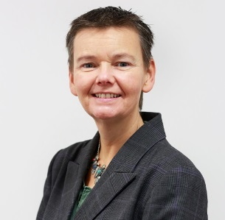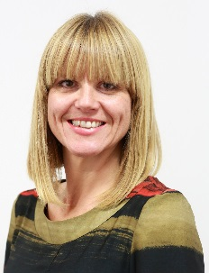

Section one
Promoting the autonomy of disabled people

At the time of writing we are in the midst of the Covid 19 Pandemic, alongside the global Black Lives Matter movement.

Breakthrough stands in solidarity with the Black Lives Matter movement protesting the appalling murders of George Floyd and others, institutional racism and wider injustices faced by BAME communities in the UK and overseas.
Actions we will take:
- We will be bold and visible in challenging racism in all its forms.
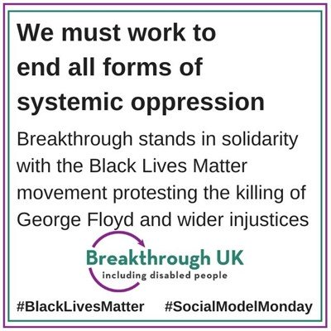
(Image shows infographic with text: We must work to end all forms of systemic oppression. Breakthrough stands in solidarity with the Black Lives Matter movement protesting the killing of George Floyd and wider injustices. With BUK logo and #Black LivesMatter #SocialModelMonday)
- We will collaborate with partners across all sectors to tackle intersectional and institutional discrimination.
- We will strengthen our links with BAME organisations to understand and act on key issues.
- We will support the capacity of self-organised BAME-led groups of disabled people locally wherever we can.
- We will continue to promote the concept of Independent Living of disabled people in a diverse cultural context.
- We will promote greater representation of BAME disabled people across all our communication channels and within our evidence base for influencing change.
- We will better understand our staff make up and development opportunities so that we can consider targeted stretch opportunities and coaching for BAME and disabled staff.
- We will assist all our stakeholders – including staff, volunteers, clients, Board and funders - to learn through accessible information how to identify and eliminate racist and other discriminatory practices.

Disabled people still face huge barriers and inequality in society, and sadly, these are increasing.

Many disabled people are still unable to participate fully in society, despite having as much a desire to work and contribute to their communities as anyone else. We will continue to work with the Social Model of Disability at our core.

Supporting our employees

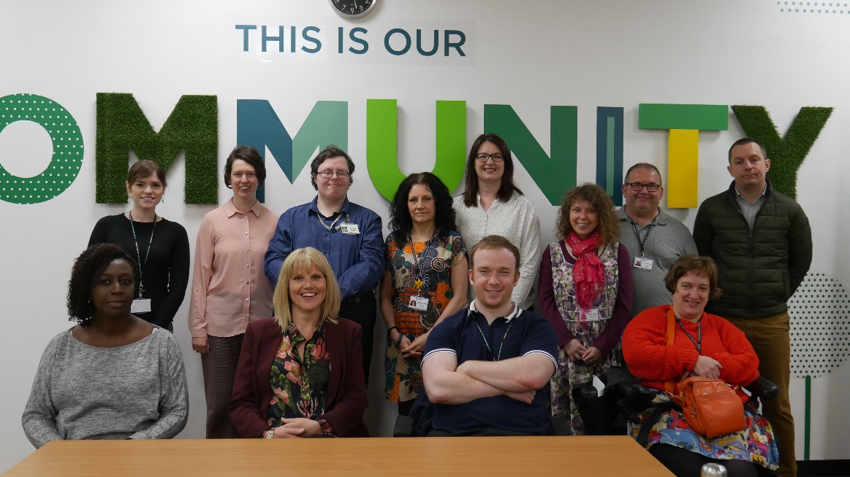

(Image shows some of the Breakthrough staff in 2019)

With 60% of staff and board members identifying as disabled, Breakthrough is leading the way in meeting the requirements of disabled people.
Our latest Investors in People assessment stated: “Breakthrough UK had created a positive ‘can do’ culture amongst its staff, driven by a credible, well-respected and experienced Chief Executive, Deputy Chief Executive and the Senior Management Team. They were continually working together with the team to ensure Breakthrough UK was a sustainable company with a long term future for all its staff. “

Social Model of Disability

Society puts up barriers for disabled people. These can be bad attitudes, poor physical access, or the way organisations do things. For example, strict 9-5 working hours exclude many disabled people who would work much better with some control over their routine.

Barriers like these stop disabled people from being fully included in everything from work, education, and housing to entertainment and travel. Once barriers are removed, everyone can participate equally.

Individuals and organisations need to recognise how they exclude disabled people, and take practical steps to change.

Every Monday we discuss the Social Model, with specific examples of common problems and solutions. Follow or join in the conversation on Twitter at #SocialModelMonday.

Example:

Image shows yellow sun and text in purple speech bubbles:

“I cannot be ‘fixed’, so please accept me for who I am.”

Disabled people don’t want pity, but an equal chance at what life has to offer.

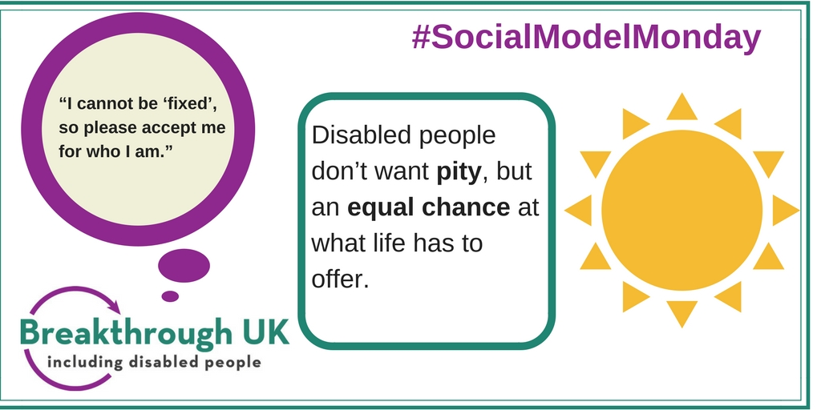

#SocialModelMonday

Section two
Breakthrough UK – who are we?

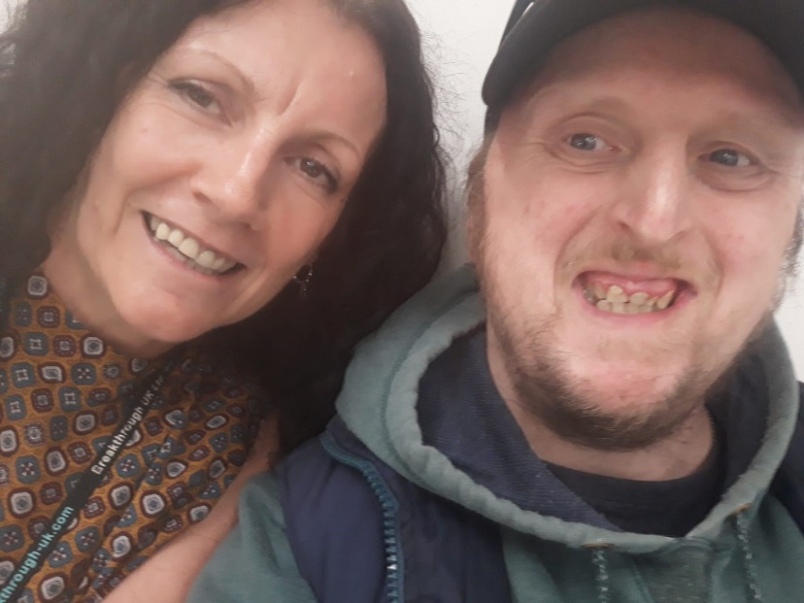

(Image shows Community Connector Tracy with client Matthew)

We’re an organisation of disabled people based in Manchester. We are led by disabled people and supporting other disabled people to work and live independently is at the heart of what we do.

Our Values and Behaviours

Vision: we promote the rights and responsibilities of disabled people

Values:

We promote the autonomy of disabled people
We are bold and visible
We are driving change

Behaviours:

We always involve disabled people
We work together with disabled people and others to achieve our vision
We create opportunities for positive change
We are person centred in approach and will empower disabled people
We use our live experience and knowledge in delivering our tried and trusted ways of working

Section three

Bold and Visible

We are proud to do things differently.
The more disabled people are included in everyday life, the more visible we become. Between January 2019 and December 2019, we worked with 602 disabled people across each of our services.

Our current services:
Community Connecting

We have seven full time equivalent staff working across central, south and north Manchester with clients with learning difficulties. Staff and clients work together identify interests and hobbies, and to connect into these activities in their communities.

During this time, we worked with 304 connecting clients.

Quote: “Now I know the bus journey so well to get to Men in Sheds. It’s a new journey I didn’t know before but now I know. I’ve liked the service of Breakthrough actually - I feel it gives me a bit of guidance... I feel more happy leaving the house really. It been really good to meet new people. My advice would be ask as many questions as possible; don’t be afraid to ask anything. I’d recommend Breakthrough to anybody.”

Alan’s connecting story

Spending a lot of time playing computer games, meant Connecting client Alan had been leading a very limited life.
He said, “I wanted to get out of the house more. I was always in the house and felt fed up and bored, and my family are quite busy.”
After meeting Community Connector Kevin, Alan got the chance to talk about and try activities that interested him.
He decided to see what the Arts For Good Health classes at St Andrews Church, Wythenshawe were like.
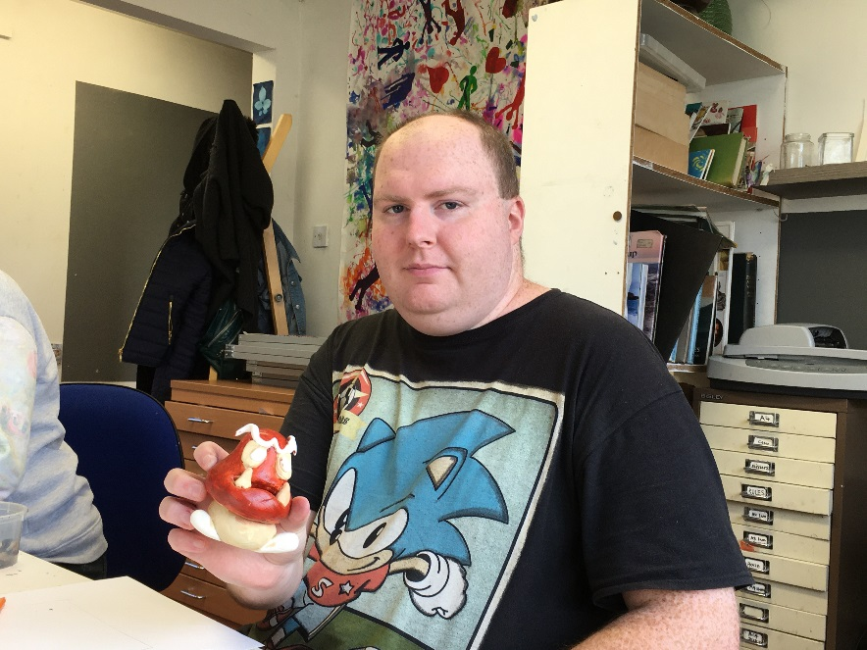
(Image shows client Alan in art class)

These creative sessions are run by Recovery Pathways Wellbeing Art Tutors, part of Greater Manchester Mental Health, and cover all mediums of art.
Alan attended the first session with Connector Kevin.
He said, “I was a bit nervous at first. But it’s felt good to meet new people.
“I’ve been drawing objects like bottles. I have also done animation and made a 3D character of Super Mario one of the main brothers in the game.”
Going to the art class has opened up a whole new world for Alan, and since first attending with Kevin he is now confident enough to go independently. The art class had led to a volunteering role in the church garden.
Alan added, “When I get out I feel a bit better, and I have more of a social life.”

Manchester Employment Service
For disabled people living in Manchester.

We have one staff member working with clients on an individual basis, supporting them into meaningful jobs.

During this time we:

Worked with 85 disabled people, 27 of whom successfully got into employment, completed voluntary work placements and completed vocational training.

Gemma’s Employment Service story
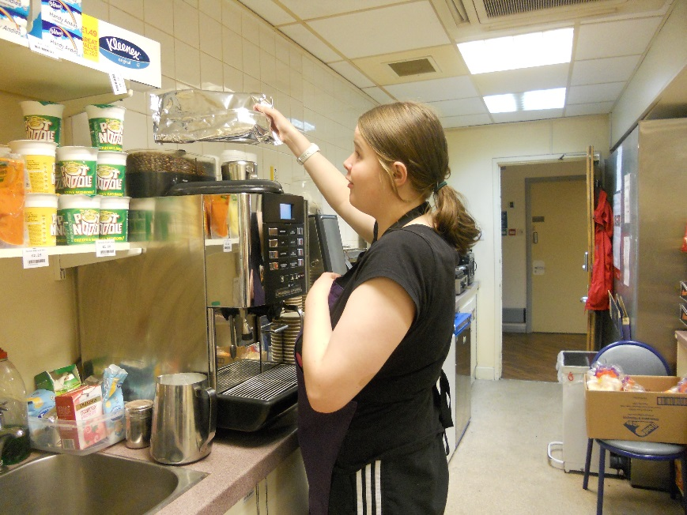
(Image shows Gemma in a kitchen)

Gemma has worked hard with Breakthrough to remove barriers and work towards her goal of securing paid employment.

Working with Gemma and her advisor at Job Centre Plus it was agreed that we could support Gemma on the right to control employment programme. During this time Gemma was supported to gain valuable work experience.

Gemma worked and completed her food hygiene level 2 certificate, and has continued to receive support from Breakthrough and has recently started volunteering at the WRVS café within the Manchester Royal Infirmary. Gemma works alongside other volunteers to deliver a valuable service to staff and visitors.

Gemma is doing an amazing job, and with the support from other team members has quickly settled in and has become a confident member of the team.

Pathways Independent Living Skills and Pre-Employability

Funded by Lloyds Bank Foundation, Pathways are a series of courses of peer group sessions in Independent Living and Pre-Employability. We worked with 170 people during this time.

We ran 499 sessions with clients reporting an increase in self-responsibility and basic living skills, improved aspirations and motivation to find work.

During this time Pathways courses became ASDAN accredited and many partnerships with local businesses were forged to provide clients with real world recruitment experiences.

On the Pre-Employability course.:

Partnership Working and Employment: Mock Interviews at Southways Housing Trust

Getting through the interview process can be challenging but disabled candidates often face additional challenges, as many HR processes are inaccessible.

This year, we spent time forging valuable relationships with different organisations, all working with us to give clients real life experiences of the world of work and being interviewed.

As part of the Pathways Pre-Employment course in Wythenshawe client Stephen Lee was interviewed by Kara Grant, Elaine Wilkinson and Carl Bacon at Southways Housing Trust within their office at Southern Gate.

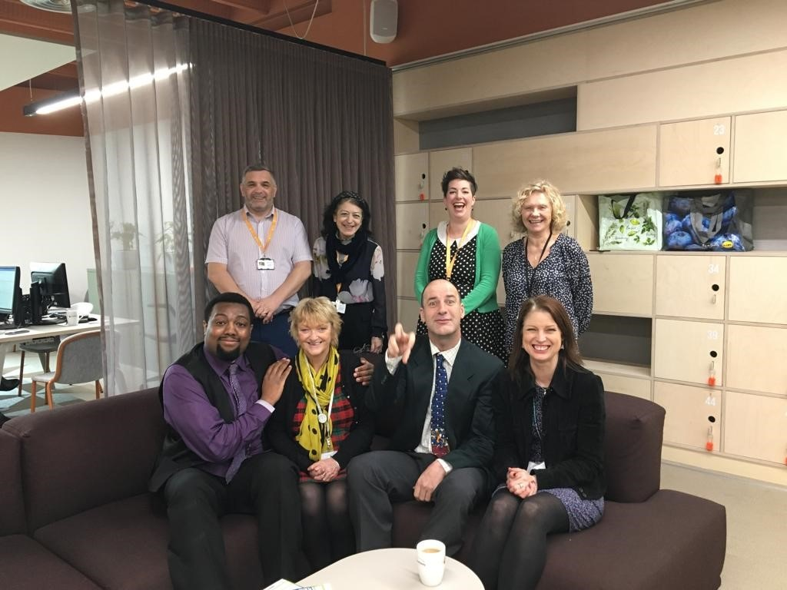

(Image shows group of Pathways clients, Breakthrough and Southways Housing staff after mock interviews)

Stephen said, “I was nervous doing my mock interview but actually really enjoyed it.
“It’s made me think about good eye contact and body language as well as giving some good examples to answer the questions.

“It has definitely made me feel more confident. The mock interview was perfect timing as I have an interview next week.”

From this cohort alone, seven clients had a mock interview at Southways Housing Trust and nine at the Royal Exchange Theatre.

Kara Grant from Southways Housing Trust said, “The interview process can be so nerve-wracking and stressful.

“We were delighted to support Breakthrough with the important work they are doing in the community by running mock interviews with the group.

“We set it up as a panel interview asked a series of questions and then gave detailed, constructive feedback. We were really impressed by the standard of the interviewees’ enthusiasm and motivation. We wish them all the best with their future interviews.”

With many thanks to TLT Solicitors, Southways Housing Trust, The Royal Exchange Theatre, Marks and Spencer and the NHS for opening up these experiences

Alex’s Independent Living Pathways story

Alex Thomas has a passion for life and is a busy person.
However, he has experienced barriers around learning new things.
Alex jumped at the chance to join Breakthrough’s Pathways course, after his support worker told him about it.
He said, “I have really enjoyed all the positive interaction, and all the co-operation and helping each other out.”
Alex, 23, completed the Independent Living part of the course with the option of going on to try the Pre-Employment part.
He added, “I go walking every week, and I go to the gym, and I do walking football at Trafford Sports Barn.
“I liked meeting everyone else and being sociable. I’ve made new friends and I would really recommend it to other people.”

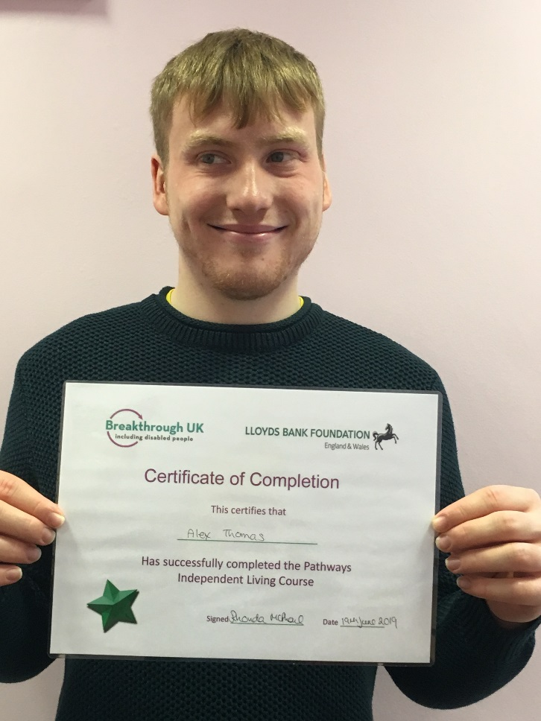
(Image shows Alex with his Pathways certificate)
On the course, Alex took part in sessions on course self-advocacy, self-confidence, connecting with the community, travel training, health and wellbeing and a cookery session.
The course has an emphasis on peer support and sharing experiences.

Video quote Donnell Charles Pathways
Transcript: “Hello, my name’s Donnell Charles, and what I love about the Breakthrough course is I’ve made plenty of new friends now, Lauren, Gary, Suzanne, Angela, Ben. Chris ad Rhonda of course and another tutor Shirley. What I love personally about the course, is about how my communication skills have improved, such as for example I didn’t always used to look people in the eye because I found having to keep eye contact very nerve wracking for me but I’ve got pretty good at it now.”

Services during this time that have now stopped

Youth Choices

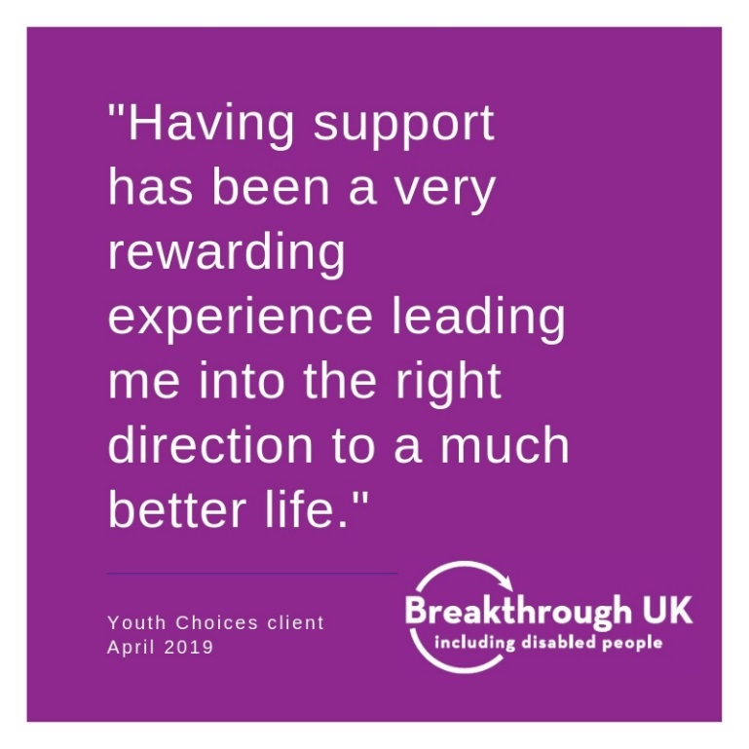

(Image shows purple infographic with quote: “Having support has been a very rewarding experience leading me into the right direction to a much better life.” Youth Choices client April 2019.)

Youth Choices worked with 41 people and held 224 sessions.

Rebecca’s Youth Choices story (pronouns they/them)

Negative experiences in school and college left Rebecca with barriers around learning in a classroom and meeting people they didn’t know.
They said, “I didn’t really like college; I was only there because I had to be…I didn’t like the room setting, I’ve had a lot of bad experiences in classes.”
When Rebecca decided to join Breakthrough’s Youth Choices course, it was simply a way for them to get out of the college classroom, but they found the experience has been entirely positive.
“I really liked the parts where we were doing team building exercise; I really liked the practical things. I do struggle with getting to know people; this has helped to overcome that.”
The negative experiences in the past left Rebecca with barriers around confidence and anxiety. This led onto feeling anxious about certain situations.
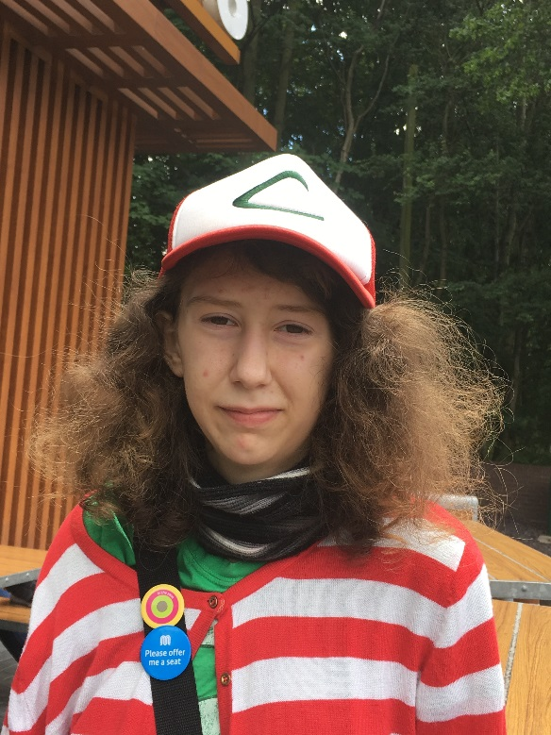
(Image shows Youth Choices participant Rebecca)
They said, “I was really anxious about using computers and I have a panic when I’m in front of one of them. I can’t stand it.”
As with all Breakthrough’s services, Youth Choices is co-designed with participants. “It was great that we could tell Richard we didn’t like the worksheets he gave us, so he changed that part with us.”
Rebecca has now gone on to join the Greater Manchester Youth Panel, using their new found confidence to fully participate and get enjoyment out of working with new people.

Section four
We are driving change

We continued to work to influence national and local public policy to bring about social change and removed discriminatory barriers to disabled people to ensure that they can play a full, active and equal role as citizens in all aspects of society.

This policy influencing work in informed by the lived experiences of disabled people. Key policy and research activities included-

- We are part of the Board of the North West Care Co-operative who via DRILL funding, are testing the development of self-directed Care Co-operative - groups of up to 10 disabled people, regardless of age or impairment, across the North West to set up care cooperative as a social enterprise enabling choice and control over who delivers their care and support, by pooling their skills, experiences and costs as a shared employer of personal assistants
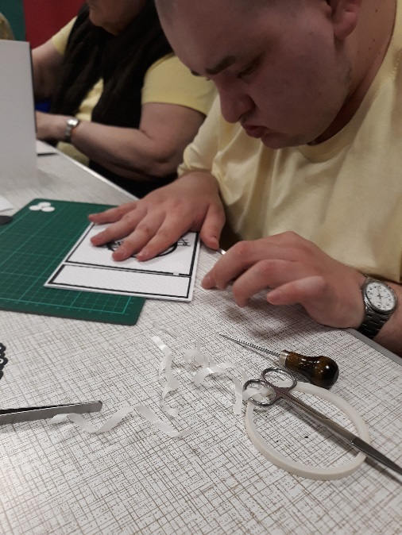
(Image shows Connecting client Kieron card making)
- We have supported the development of the Memorandum of Understanding (MOU) between the VCSE and Manchester Local Care Organisation
- We are a supporter of the Greater Manchester Combined Authority’s consultation on a draft Good Employment Charter and we have been influencing the measures used to demonstrate an Inclusive Employer as part of the charter
- We presented the findings from our engagement work on disabled people’s experiences of NHS screening programmes to the Board of Manchester Health and Care Commissioning (MHCC) in November. 107 disabled people took part in the project to share their experiences of accessing NHS screening programmes - such as cervical screening, breast screening and bowel cancer screening - and make recommendations for change. Disabled people’s participation in NHS screening programmes is low across the board, and Manchester has the lowest uptake of screening amongst disabled people across Greater Manchester. Key findings include:
  - The majority of disabled people who took part in the project had faced barriers to accessing NHS screening programmes
  - Lack of effective implementation of the Accessible Information Standard
  - Attitudes and assumptions led to people not getting tested, or being encouraged not to have tests by family members or support staff
  - Inaccessible mainstream tests were a big issue, coupled with lack of easily available information on the accessible alternatives
  - Overreliance on websites for information on screening, digital by default
  - Poorly trained front line staff on helplines and reception with little knowledge about how to make information and services accessible
  - Intersectional factors - for example language barriers, PTSD from abuse or trauma
  - The role and availability of support workers and Personal Assistants (PAs) was a recurring theme
  - Potentially poor access was the biggest deterrent to people attending appointments, followed by difficulties getting an appointment, previous bad experience and transport barriers
  - Lack of accessible home testing options also a big issue

Recommendations were drawn from the enablers suggested by participants, across the 12 pillars of Independent Living. The report can be accessed at:
https://www.mhcc.nhs.uk/news/engaging-with-disabled-people-on-experiences-of-and-barriers-to-accessing-nhs-screening-programmes/
- We supported Manchester City Council to produce a Social Model of Disability focused Joint Strategic Needs Assessment. This focused on the evidence commissioners and partners need to remove disabling barriers across the design and delivery of work. It is available at:
https://www.manchester.gov.uk/downloads/download/7145/adults_and_older_people_jsna_-_disabled_people_social_model_of_disability
- Our Manchester Strengths Based Development Co-design work - we continued to support the development of a new strengths -based workforce development programme

- Established the first meeting of North West Network Policy Group - Cheshire CIL policy officer, Disability Equality North West and Breakthrough agreed joint approaches/ key messages to strengthen our voice and thought leadership across the region. Our policy officers began to meet regularly to progress this work and share approaches

- Greater Manchester Mayoral Disabled People’s Panel. We gave considerable support to developing the approach of the now established Panel and recruitment of its workers. Our CEO was elected as Co-Chair

- Successfully facilitated a review of the Our Manchester Disability Plan (OMDP) by Manchester City Council Chief Executives department to enable the OMDP to move to the next level of its development. We continued to give significant strategic support to the OMDP Partnership Board, Engagement Group (DPOs), Employment Workstream and the Health & Social Care Reference Group

- This successful training pilot commissioned by Manchester Health & Care Commissioning was delivered to managers from the NHS, Manchester City Council (MCC) and the voluntary (VCSE) sectors last year in collaboration with Result CIC

- A networking/champions event for participants of last year’s successful Disability Inclusion Training, funded by MHCC, took place in March. It was facilitated by Result CIC and Breakthrough

- Breakthrough continues to support the local grassroots campaign demanding that Manchester City Council make suitable access improvements to the currently inaccessible Peterloo Memorial

- Our CEO attended a Centenary NCVO Evening Reception hosted by the Queen at Windsor Castle

- Our CEO spoke at Manchester Local Care Organisation Freedom to Lead Conference

- Manchester Local Care Organisation Neighbourhood Lead Recruitment – we were involved in the recruitment panels for the remaining MLCO Neighbourhood Leads to provide a community perspective and ensure those recruited understand the value and importance of a person and community centred approach to the role
- We also continued to position ourselves within relevant strategic forums to influence local, regional and national policy and practices.

To this end, our CEO served as a member of:-

Equality and Human Rights Commission Disability Advisory Committee
National Independent Living Strategy Group
North West Network of Disabled Peoples Organisations
GM Mayoral Disability Panel – Co Chair and member
GM Voluntary and Community Sector Leaders Group
Macc Health and Wellbeing Leaders Group
MHCC Inclusion and Social Value Panel
Manchester Person Centred Community Approaches Working Group
Our Manchester Disability Plan
Our Manchester Forum
Our Manchester Investment Board
Our Manchester Building Services Better Together
Manchester Adult Education and Skills Plan – Steering Group
SCOPE – Disabled Peoples Organisation Reference Group and Support to Work Evaluation Stakeholder Panel

Section five
Peer groups, volunteering, women’s project and the Disability Design Reference Group

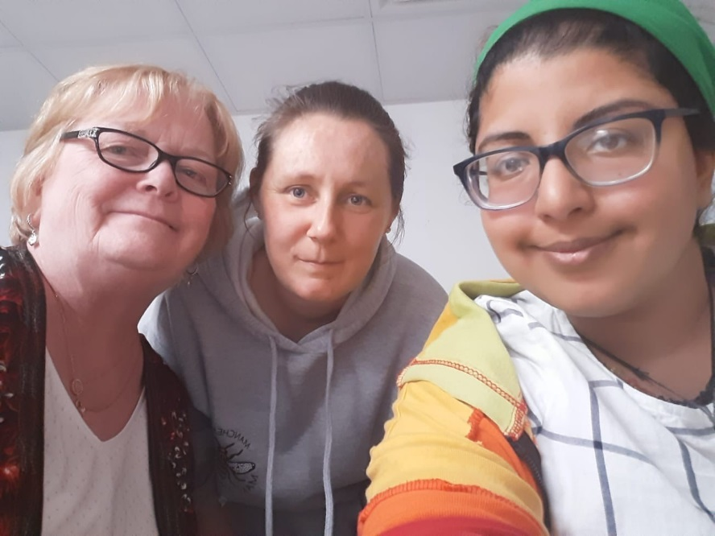

(Image shows members of disabled women’s peer group)

At its core, peer support is about the relationships that people build as they share their own experiences to help and support each other.

In 2019, we were awarded a grant from Mind to facilitate a peer group of disabled women as part of their Women’s Side by Side Mental Health Peer Support Programme.

The group ran weekly throughout the year from late April onwards and 15 disabled women took part across the year. Members established the remit of the group themselves. A key aim was for disabled women to feel empowered and confident to express themselves with increased advocacy skills, agency self-belief, self-esteem, choice and control.
Members of the group all made strides in asserting themselves and speaking up - this was particularly evident recently when
members decided to change the remit of the group.

Members reported that they are now feeling more confident. Some are now much more active in external activities too.

All of the women who have been involved in the group have said they joined because they wanted to meet other people and many identified that they felt socially isolated.

93% of participants said they felt good at the end of sessions, compared with 58% at the beginning of them.
Building trust and rapport was extremely important so that people feel that they were in a safe space to share.

The main shared ground for this group was around experiences as
disabled women and so disability was the first area that members chose to explore, especially around barriers to access in public spaces, issues around the recruitment and retention of personal assistants
and within healthcare.

We supported members to explore this by providing training in the Social Model of Disability. This really empowered people to
identify barriers they had all experienced, and talk about what they wanted to see change, including things to campaign on.

Women supported others in the group who have been through similar experiences, encouraging them, pointing out their strengths, sharing knowledge and letting them know that things can get better.
Anonymous quotes from participants include:
“Extremely interesting conversation regarding barriers and social disability model. Nice to know other people have experienced similar issues.”
“Since being in this peer group my confidence and ability to socialise with others have improved. I also am aware that my barriers can be overcome and I'm learning how to be assertive and adaptive to my environment”

Democracy Disability Devolution Women's Project
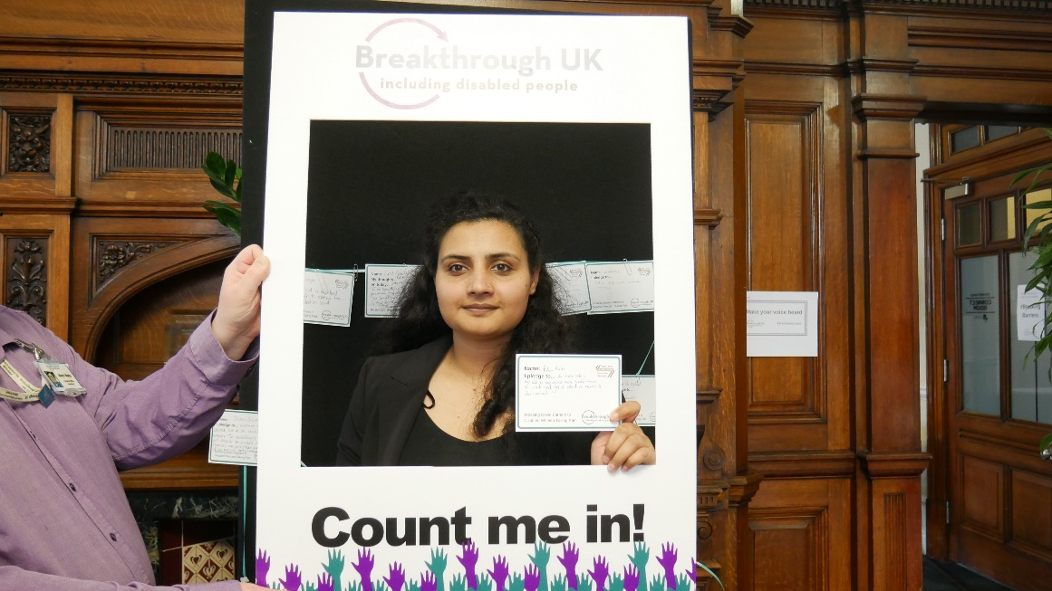
(Image shows women making pledge at event)
This Government Equalities Office funded project ran from November 2018 and ended on Monday 18th February 2019. It aimed to bring together disabled women from a range of backgrounds, supporting them to understand the importance of democracy and representation. Also to enable participants to consider their own role in civic life, develop self-advocacy skills, and engage wider stakeholders and decision makers such as MPs, peers and councillors.
34 disabled women and 24 organisations actively participated in the project. Throughout the project, we:
- Spoke at 45 Greater Manchester events (women’s, political or impairment specific events), urging several to improve their access to ensure disabled women could fully participate.
- Corresponded with 350 groups about the project and its aims
- Held one to one meetings with political agencies e.g. Parliament Project and local councillors.
- Relationship building led to two disabled local women attending the House of Lords for Voice Box. It also led to Gemma Nash (Breakthrough Trustee) speaking at the Pankhurst Fawcett Scorecard meeting and launch event for GM4Women2028. We were also invited to speak at Salford University.
- Held group meetings with disabled women in Salford, Trafford and Stockport.
- Organised two conference-style events in February, at Greater Manchester Chamber of Commerce. MC’d by Michele Scattergood:

The first event on 8th February was an afternoon engaging 35, mainly organisational, delegates to break barriers to disabled women’s representation. This featured networking and lunch and motivational talks from Athena Stevens (a disabled woman with various experiences including as Women’s Equality Party Spokesperson), Gail Heath CEO of Manchester Women’s Aid / Pankhurst Trust which both prompted Q & A. We screened a video by Baroness Campbell on her journey into politics, recorded specifically for our event. https://www.youtube.com/user/BreakthroughUKLtd
Delegates each participated in three discussions on inclusive outreach and engagement, accessible information, accessible event organising and inclusive language. Many pledged to take action to be more inclusive to disabled women.
The second event aimed at individual disabled women had 27 delegates. It featured talks from Jackie Driver (Equality & Human Rights Commission), Rachel Wise (disabled woman, local council candidate), Eve Holt (Cllr and DivaManc co-founder) and Ribia Nisa (Labour candidate) all followed by active Q & As and discussion.
Disabled women facilitated zine-making sessions and book reading and discussions from Lorraine Gradwell’s ‘More Together than Ever’ about disabled women’s experiences.
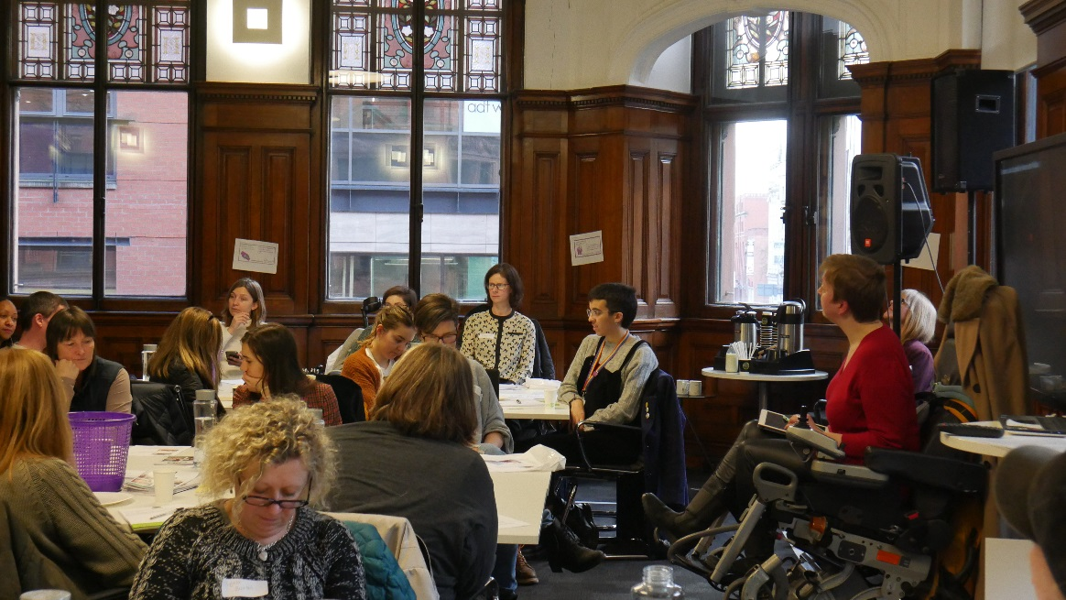
(Image shows women’s event speeches)
We held co-production workshops to create a Passport to Politics which we are renaming ‘Route to Representation’. This will give guidance to groups and allies on how they can be fully inclusive, and share tips, strategies and information to enable disabled women to play a full role in civic life.
Disabled women met and linked up with other individuals with a common goal, and learnt about and discussed how to assert their civil rights and participate. A key call from disabled women was the establishment of a local peer network of disabled women.
Disabled women’s pledges included:
- “Keep fighting even when it’s exhausting”
- “To build a local network, attend local meetings and join campaigns”
- “Keep linking up with other disabled women”
- “Do all I can to support development and continuation of a disabled women’s support network.”
- “To speak up more about accessibility issues and be more assertive in asking for what I need”
- “Take legal action whenever I experience discrimination or disabling barriers as that is the only way that change will be recorded and effected”
Organisational participants were challenged to address the accessibility and inclusion of events and services, and work closely with disabled women and organisations to provide platforms for disabled women. Collaboration was a key theme and groups expressed a strong desire to work together strategically to remove entrenched barriers to disabled women’s participation.
Organisation’s pledges included:
- “To encourage more disabled women to understand local elections”
- “Try and get a disabled young woman to attend the Manchester election count”
- “To challenge own organisation on involvement and practice.”
- “To look at our accessibility when we put events and services in a more informed and comprehensive way so as to be as inclusive as possible and campaign for event venues to make them more accessible”
- “Be bold in challenging people organisations and networks that fail to connect with and include people with disabilities. To actively include within DivaManc Parliament Project and politics”
- “Work more closely with disabled women and organisations on how our events can be more accessible for all and image descriptions.”

The Route to Representation has been produced. Find out more on our website at: https://www.breakthrough-uk.co.uk/news/womens-events-a-great-success

Volunteering at Breakthrough

Volunteers play a crucial role for us. Without volunteers we would quite simply, be stuck. For the individual, the volunteering role is of great benefit too. Reducing isolation, improving confidence and improving skills to name a few.

Michael’s volunteering story
During this time Michael volunteered on Pathways Independent Living and Pre- employment courses, which he had been a participant in.
He said, “I enjoy helping people and it helps me. I have met wonderful people and by speaking with others I am always learning. It’s positive finding out it’s not just me that’s like that, it’s like a club of people that comes together and empathises with each other.”
Pathways Co-ordinator Rhonda said, “Michael has been a huge asset as a Pathways volunteer. He is extremely creative and uses this talent to bring a new element into the sessions. We ran an Independent Living Pathways for Proud and Loud Arts, and Michael used his drama and performance experience and skills to take the lead and create a number of roleplaying learning activities, which was hugely successful!”
Michael has organised educational activity trips, including a trip to Manchester Central Library. He assisted the co-ordinators with sourcing venues and supporting people during training sessions.
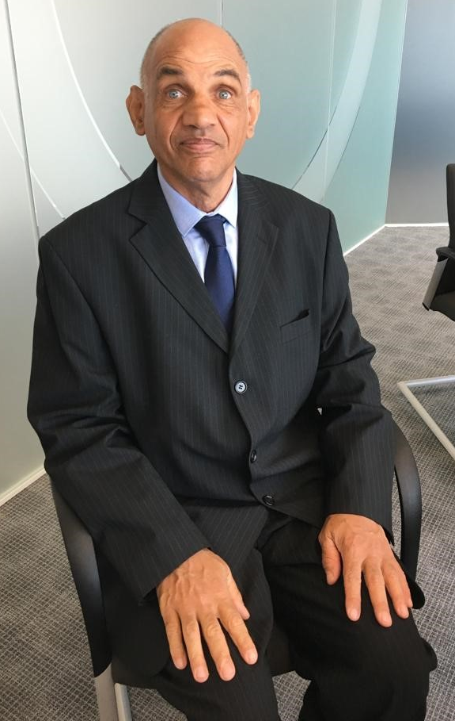
He also completed Social Model of Disability Training and commented that at Breakthrough “you’re spoken with, not spoken to and people (volunteers and participants) feel they have an interest in Breakthrough because they can have a positive input. ”
Michael also represented Breakthrough at Melland School Xmas Fair and also helped other former clients with a fundraising event.

Michael talks about his favourite volunteer event at Manchester Central Library, “I set up a guided tour so participants could experience the wonderful modern Manchester library. It was heart-warming that a participant felt comfortable and confident enough to play the library piano. I was glad it

(Image shows volunteer Michael Taylor)

went so well and we had a great turnout and afterwards people wanted to join the library, it prompted some to go again.”

Disability Design Reference Group

Now in its 11th year of operation, the DDRG is a huge success story. The group is made up of disabled people from across Greater Manchester, who have a range of impairments and can share their lived experiences of the challenges travelling on public transport.

Breakthrough manages this award-winning group on behalf of Transport for Greater Manchester.

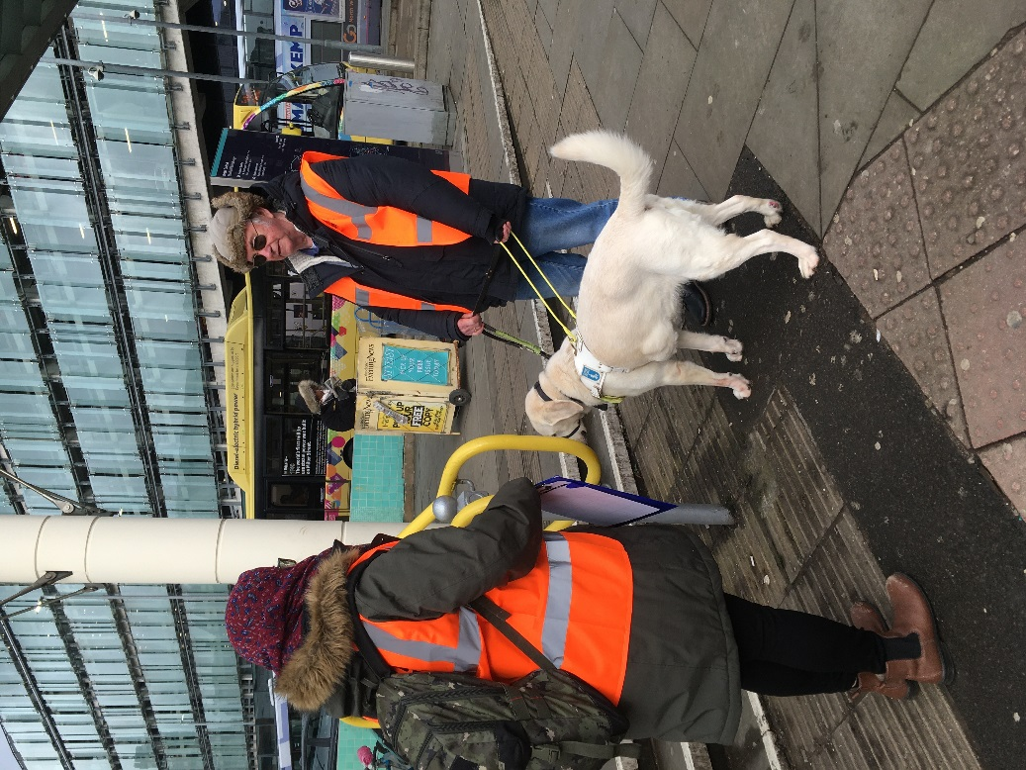

(Image shows DDRG member Frank Salt with assistant dog Lewis and TfGM staff at Metrolink stop.)

It has proved itself essential in removing barriers to accessible transport and travel, ensuring as many people as possible are able to use public transport services.

During 2019, the DDRG has:

Been on two site visits
Held 11 DDRG meetings

In November the DDRG carried out a sit visit to Crumpsall Metrolink tramstop where improvements as part of the new Trafford park tram line were being made.

As a direct result of the recommendations made by DDRG members, Crumpsall stop now has:

High visibility bands around the black bollards at the top of the new inbound ramp, and on lighting columns

Vegetation has been cleared at the top of the new ramp to make visibility clearer at night
External corners on the tapping rail on the inbound ramp have been filed down and rounded, as the edges were far too sharp

Section six
Plans for the future

We have set our key objectives for the next three years.

These are part of our Strategic Plan, which we co-designed with Breakthrough clients, board and staff members at the end of 2018.

Influencing government, local, regional and national agencies to address barriers to disabled people’s participation:

We will continue to aim high and be a leader in the field of disability issues and a ‘go to’ organisation for opinion for public and VCSE sector, and other disabled peoples organisations.

We will collaborate to create change and influence, and be focused in our influencing.

We will develop a key ‘voice’ campaign about an issue that really matters to disabled people.

Enabling disabled people to pursue and develop their skills, aspirations and careers:

We will continue to ensure co-designed and person-centred employment support, and build on our early successes of peer-led support.

We want to work more collaboratively, and develop partnerships to develop and deliver services.

Further into the future we want to develop an ‘in work’ coaching service and increase our training offer to disabled people and their families.

Providing services so disabled people have greater choice, control and independence, and connect into their communities in a positive way:

We want to extend our successful Community Connector and Pathways services, develop our volunteer base to increase Activity Mentors, and provide great volunteering opportunities to disabled people. Into the future, we want to develop an advice and information service.

Working towards being financially stable with healthy growth grounded in our ethos and principles:

We always want to improve – in 2019, we will improve internal systems and invest more in staff. We will develop a managerial succession plan.

We have set ourselves a big aspiration to develop a ‘2022 Enterprise’ and scope a major fundraising plan to get us there.

Get involved with us
Subscribe to our newsletter or bulletin.

Visit our website
www.breakthrough-uk.co.uk

Offer work
or voluntary placements to our clients within your organisation.

Volunteer with us,
in our office or at one of our groups.
Make a donation.

Thank you
Without the support of our funders, we couldn’t work with our clients, or the cause for independence and participation.

Breakthrough UK
Follow us on Twitter: @BUKCommunity
Facebook.com/BreakthroughUKLtd

Telephone: 0161 234 3950,
Text directly: 0793 994 3383 or
Email us: admin@breakthrough-uk.co.uk

The Kevin Hyett Suite, Abraham Moss Centre, Crescent Road, Crumpsall M8 5UF

