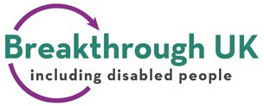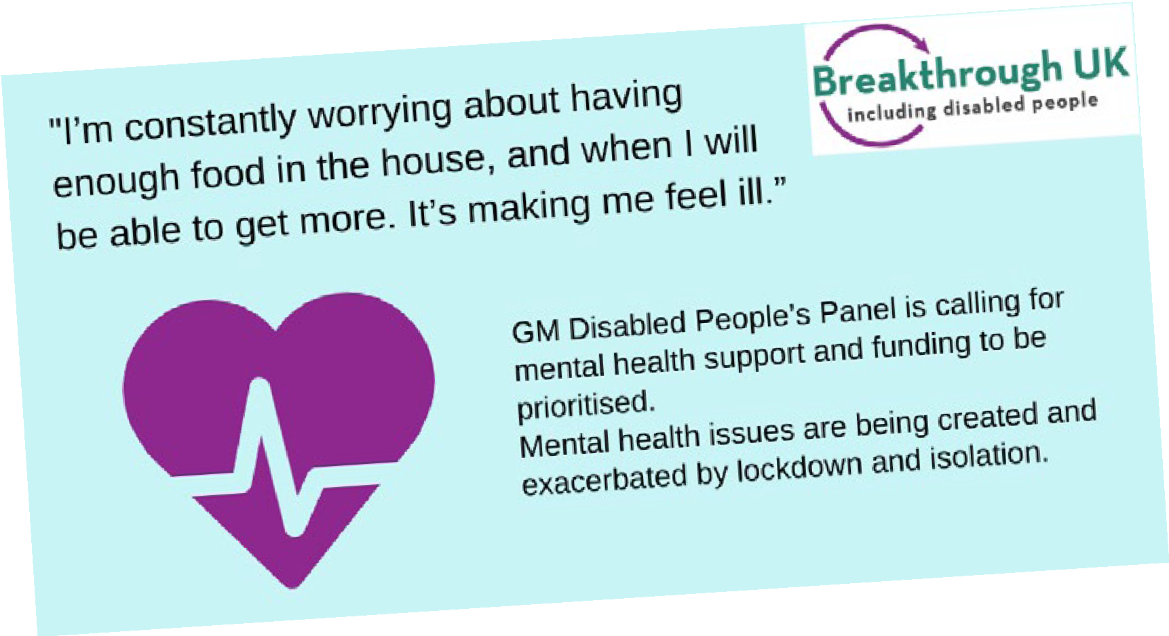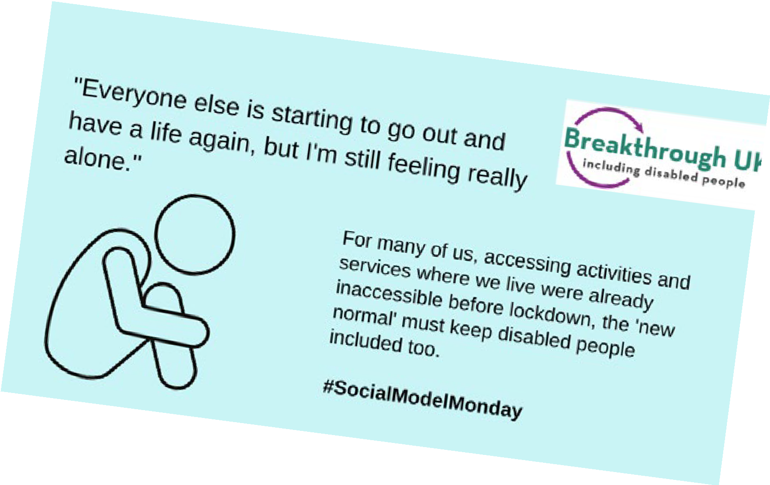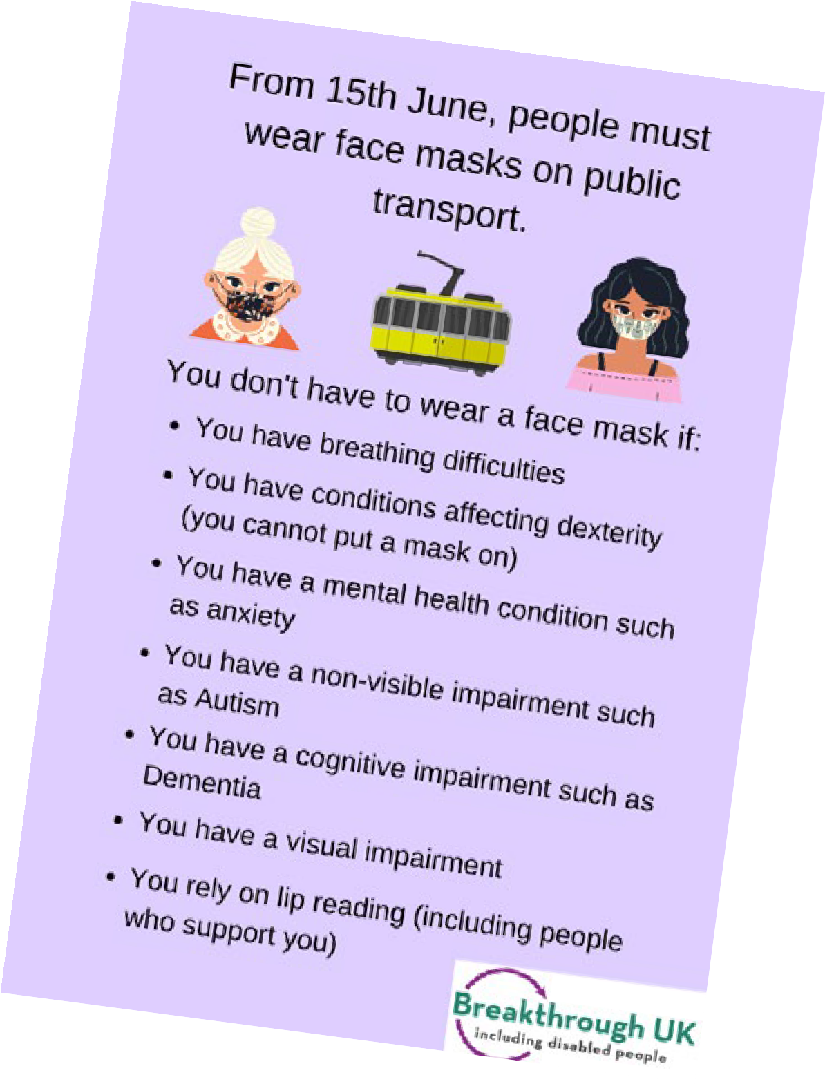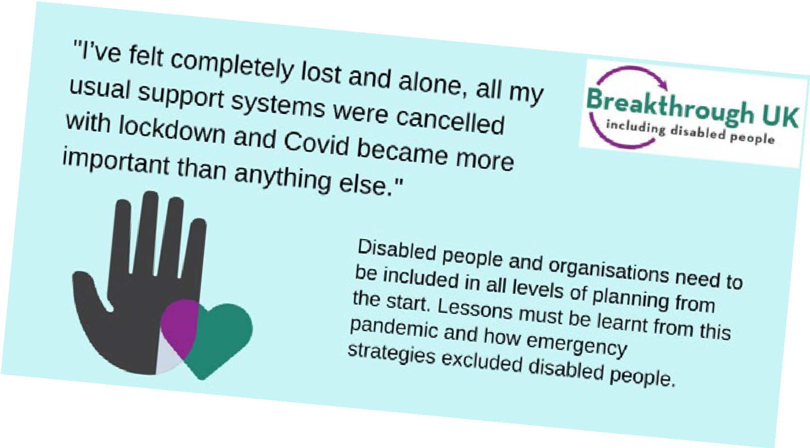IMPACT REVIEW
Breakthrough UK April 2020 – April 2021
The Social Model of Disability is at the core of Breakthrough’s being and its very existence

1

2
CONTENTS
Section one
Promoting the autonomy of disabled people
05
Section two
Breakthrough UK – who are we?
10
Section three
Bold and Visible - our services
12
Section four
We are driving change – our voice
18
Section five
Peer groups, volunteering and the Disability Design Reference Group
22
Section six
Our plans for the future
26

Introduction
We could never have imagined that when the time came to write our next Impact Review, the Covid 19 Pandemic would still be with us, and that our lives and the way we work would have completely changed.
For the time period covered in this Impact Review, we would like to thank all our Board, staff, funders and partners for a good year in the face of unprecedented challenges.
As we slowly work our way through the government’s road map out of lockdown, we continue to work hard to adapt and face the ever changing situation
Breakthrough has been a key partner in Covid response and recovery work in Manchester, working in partnership with colleagues in Manchester City Council, the NHS and other Disabled People’s Organisations to forge a fair and equitable recovery route for disabled people.
At this time the Covid vaccine programme is being rolling out and we are supporting colleagues to ensure that the process is as accessible as possible.
With most areas of society closed to the public it has been a challenge to keep clients active and engaged. But we are delighted that we’re still working with a large number of disabled people despite this.
Never before has it been this important to connect in any way we can to help reduce isolation, and each of our services has played a huge role in keeping people active and included.
As expected, Breakthrough’s services have undergone big changes with all staff working from home remotely.
Our service model continues to change, but grows from strength to strength and includes developing:
Independent living skills
Community connecting
Employment support
Pre- employment Skills
Peer support groups
Our Community Connecting service worked with 200 clients on a face to face and then digital service, when lockdown restrictions prevented mixing.
Our Independent Living Course and Pre-employment Pathways courses, have worked with 78 clients inclusively, while our Pathways2Work courses worked with 32 people.

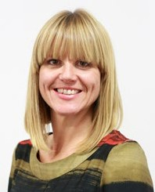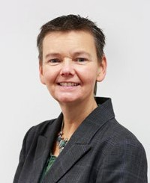
Looking to the future we re-set our Business and Growth Strategy during the Pandemic
We will be carrying out feasibility work for a number of new business areas, including a Social Enterprise to provide training and employment opportunities for disabled job seekers to deliver our aims and support our sustainability.
Throughout this difficult year, ensuring the voice of disabled people is part of local, regional and national forums remained a firm priority for us. Our Chief Executive Officer is a member of the Equality and Human Right Commission Disability Advisory Committee, an active member of the national Our Voices group and she contributes to a number of Greater Manchester forums. Our CEO also Co-Chairs the Greater Manchester Disabled Peoples Panel and we have led out on a strategic review of the Our Manchester Disability Plan.
We now co-ordinate a new disabled people’s COVID health engagement group and we are looking forward to launching new forums such as Manchester Disabled Peoples Panel - a brand new forum of lived experience for the city.
Our voice travels across the UK. We continued with our #SocialModelMonday campaign and newsletters, and published our key messages via our social media feeds.
Jackie Driver Chair
Michele Scattergood CEO
Section one
1

Promoting the autonomy of disabled people
Disabled people still face huge barriers and inequality in society, and during the pandemic these have increased further.
The onset of Covid 19 has clearly highlighted the inequalities already facing disabled people, and exacerbated how society is still unfair for many.
During this time, Breakthrough has been a key organisation in working towards a fairer system. This work included taking a lead role in developing the Greater Manchester Big Disability Survey during the first lockdown of 2020. This
highlighted key areas of inequality facing disabled people in the early months of the pandemic.
Greater Manchester Disabled People’s Panel made a list of recommendations based on responses. These included recognising digital exclusion as a key issue during this
pandemic, that digital inclusion is an urgent priority and that accessible information be implemented and produced consistently.

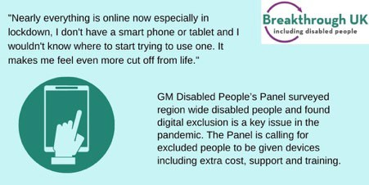
Read the full recommendations via this link
· GM Big Disability Survey

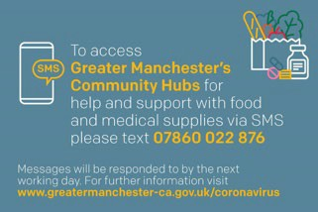

We were instrumental in ensuring Community Hub support for Greater Manchester residents was accessible, with our Greater Manchester Community Hub text service.
The dedicated text service is operated by a Breakthrough member of staff and removes communication barriers
for those people who find phone calls and online forms a barrier.
The text service has been helping on average 70 enquiries a month

Our Covid recovery work has included the setting up and facilitating of the Disabled People’s Engagement and Sounding Board, one of a number of Sounding Boards bringing together marginalised groups to highlight inequalities around the pandemic.
The Sounding Board, which held its first meeting in December, has eight member organisations and has covered topics ranging from shielding and social distancing to vaccinations and hospital visiting.
A key part of the Sounding Board project was the translating of the most important official Covid messages and announcements, into accessible communications.These were shared on our Covid Accessible Information Hub.
· Covid accessible information hub

Supporting our employees
With an average of 60% of staff and board members identifying as disabled, Breakthrough is leading the way in meeting the requirements of disabled people.
The pandemic has changed the way we deliver services, and so has changed the way we work as a staff team.
Leaving our central office at Abraham Moss for a sudden change to remote home working brought many challenges, and saw us quickly embrace online meetings and remote working WhatsApp groups to keep staff connected.
Throughout this we have continued to support staff in their new way of working with the continuation of monthly meet ups online, social groups and virtual team lunches.
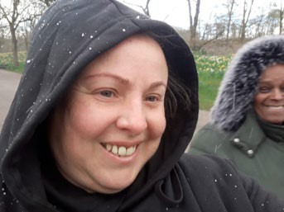
Image: Community Connector Vicky Howarth with client Jackie, part of the Walking Wheeling group

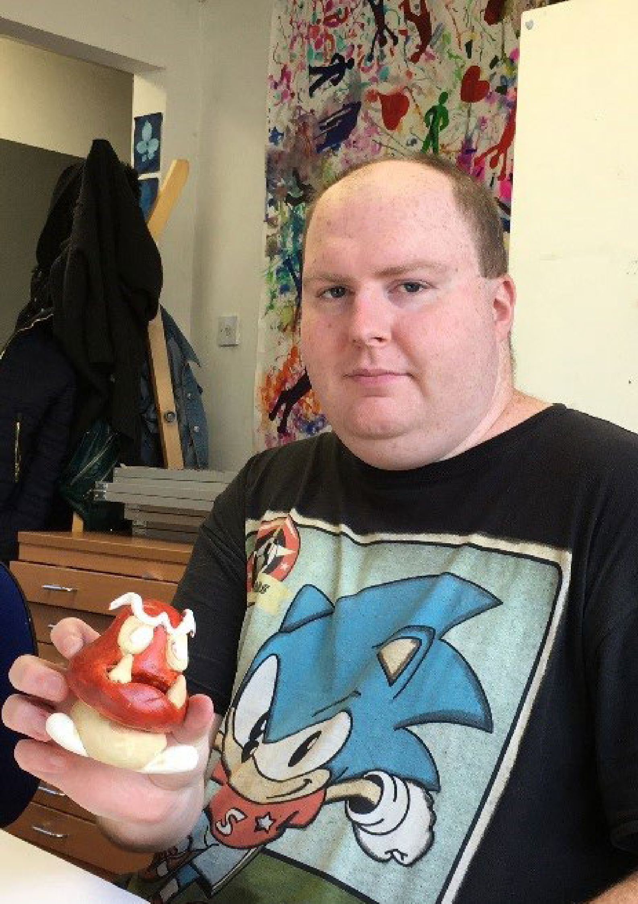
9

Social Model of Disability
Society puts up barriers for disabled people. These can be bad attitudes, poor physical access, or the way organisations do things. For example, strict 9-5 working
hours exclude many disabled people who would work much better with some control over their routine.
Barriers like these stop disabled people from being fully included in everything from work, education, and housing to entertainment and travel. Once barriers are removed, everyone can participate equally.
Individuals and organisations need to recognise how they exclude disabled people, and take practical steps to change.
Every Monday we discuss the Social Model, with specific examples of common problems and solutions. Follow or join in the conversation on Twitter at #SocialModelMonday.

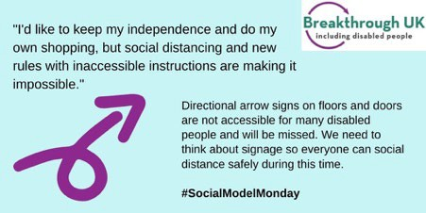

8

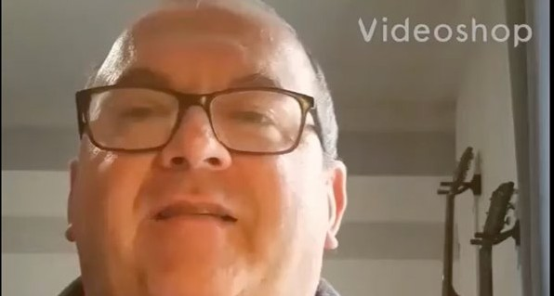Breakthrough UK – who are we?

2019
who we are what we do

2022

Community Connector Kevin, who created a ‘tips to structuring your day’ video for clients during lockdown
We’re an organisation of disabled people based in Manchester. We are led by disabled people and supporting other disabled people to work and live independently is at the heart of what we do.

Our Values and Behaviours
Vision: we promote the rights and responsibilities of disabled people

Values:
- We promote the autonomy of disabled people
- We are bold and visible
- We are driving change

Behaviours:
- We always involve disabled people
- We work together with disabled people and others to achieve our vision
- We create opportunities for positive change
- We are person centred in approach and will empower disabled people

Influencing
government, local, regional and national agencies about barriers to disabled people’s participation

Work by
  - developing a 2022 ‘enterprise’
  - scoping a major fundraising plan for enterprise 2022
  - improving our internal systems
  - investing more in our staff
  - developing a managerial succession plan

Working
towards being financially stable with healthy growth
grounded in our ethos and principles

Influence by
- being a leader in the field of disability issues and a
‘go to’ organisation for opinion for public and VCSE sector and other disabled people’s organisations
- collaborating to create change and influence
- developing a key voice campaign

Provide by
- developing an advice and information service
- extending our community connector and pathways offer
- developing a coaching offer
- developing our volunteer base

Enabling
disabled people to pursue and develop their skills, aspirations
and careers

Enable by
- developing ‘in work’ coaching service
- increasing our training offer to disabled people and their
families
- developing collaboratively and develop partnerships
- ensuring co-designed, peer led and person centred
employment support

Providing
services to enable disabled people to have greater
choice, control and independence and connect into their community in
a positive way

  - 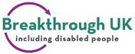We use our lived experience and knowledge in delivering our tried and trusted ways of working
Section two
2
Breakthrough is an organisation of disabled people
www.breakthrough-uk.co.uk Registered charity number 1078009

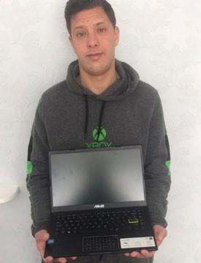

Anwer’s Connecting story
Connecting client Anwer Mulahal struggled to move forward with his life as he speaks no English.
Connector Kevin worked with him using Anwer’s sister as a translator. Anwer’s overall goal was to enrol on online English classes, to enable him to participate fully in life.
Researching how Breakthrough could help, Kevin found an IT grant opportunity with a Gaddum trust fund. After funds were awarded, we were able to supply Anwer a laptop.
Now Anwer is engaging fully with the Connecting programme and beginning his language class
Speaking via his sister, Anwer said, “I’m really happy with my laptop because I want to learn in the future.”
Section three
3

Bold and Visible
We are proud to do things differently.
The more disabled people are included in everyday life, the more visible we become. Between April 2020 and April 2020, we worked with 310 disabled people across each of our services.

Our current services:
Community Connecting
We have 16 staff working across central, south and north Manchester with clients with learning difficulties. Staff and clients work together identify interests and hobbies, and to connect into these activities in their communities.
During the lockdown periods of the pandemic, connecting services were delivered virtually in a variety of ways dependant on how the client could best engage. This included Zoom video call, phone calls, WhatsApp groups and materials being posted.
During this 2020-21, we worked with 200 connecting clients, and delivered 1,771 sessions.
In the North of the city, 70% of clients reported attending new activities in a month. And in the South, 55% said they felt an increase in confidence talking to other people, and 56% felt an increase in confidence travelling independently.
Both staff and clients created videos to support each other during periods of isolation. Here, client Lauren shares an exercise video as part of the group’s ‘Moving Mondays’ theme.

Left: Here client Lauren shares an exercise video as part of the peer group’s ‘Moving Mondays’ theme

Manchester Employment Service
For disabled people living in Manchester
This year has seen a significant worsening of the position of disabled people in the labour market. Regrettably, we know many disabled people who have been amongst those furloughed or made redundant as a result of Covid.
Given the inequitable position of disabled people in the workforce prior to Covid, this is very concerning. Safe, accessible and sustainable job opportunities have been scarce during this time and this has had a direct impact on our work with disabled people around employment.
In response to these challenges, our employment programme has been redesigned to fit a digital offering and will focus on building partnerships in South Manchester as part of a new Manchester City Council pilot.
Alongside this, we continue to speak out to push for accessible employment opportunities and development in mainstream workplaces. Key to this will be ensuring that employers meet their obligations under the Equality Act to make reasonable adjustments to recruitment processes and within a range of physical environments – not just home working.
The pandemic has shown that employers can be agile and flexible in working practices. We want to see this new culture sustained as we come out of Covid.

Pathways short course programme
Pathways are a series of courses or peer group sessions in Independent Living and Pre-Employability. We offer:
- Independent Living – short course
- Digital Inclusion - face to face and free device
- Preparing for Work – short course
- Pathways to Work – coaching and job clubs
During this time we worked with 36 clients on Independent Living, and 42 completed the Pre-Employability part.
Our Pathways 2 Work sessions saw 31 clients over 12 months, with six awaiting voluntary placement start dates, 13 attending education/training and four securing paid employment.

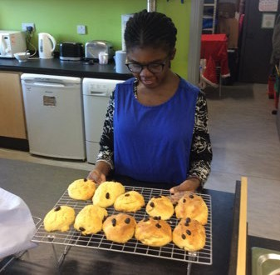Image: Toyosi enjoys baking during a practical cookery skills session
The courses, which moved over to Zoom online platform during national lockdown, presented new challenges in keeping clients engaged but we are delighted with the results and feedback

Toyosi’s Independent Living Pathways story
Toyosi was referred to Pathways following her time with the Community Connectors.
While very shy at first, Toyosi grew in confidence and took part fully in the sessions, particularly enjoying the cookery session. She said, “I really enjoyed it, it was fun.”

Kelly’s Independent Living Pathways story
Taking part in Pathways IL course was Kelly’s first experience of working with Breakthrough, having been referred through her Occupational Therapist. Feeling she had a low level of independence, Kelly wanted to improve her life skills.
During the course staff worked on breaking down Kelly’s barriers in building confidence, her low level of independence and a feeling of low skills level.
Kelly said, “Breakthrough has given me structure, helped me with socialising and helped me with my mental health- feeling good with myself”. Following on, Kelly has joined the Pre-employment course.
Kelly’s goals:
- Gain confidence
- Improve on her team building and listening skills

Clients told us about Pathways Pre-employability
Client William said, “The course has been really good and has bridged the gap between leaving college and finding work. I don’t feel as isolated as I did before due to the social aspect and I’ve learned things to help me to get a job.
“Doing the course online has been good though I would prefer face to face when we can. The good thing though about online is that it’s helped me to still maintain contact with people to socialize. The mock interview was really good too”.
William’s goals:
- Start Pathways2 Work
- Start Pathways Independent Living Course
- To find a job – shop work / warehouse

Laura
“I really enjoyed the mock interview and this was one of my favorite bits about the course. I enjoyed the discussions and I want to get a job now. I would like to do more with Breakthrough UK my confidence has grew since being on the Pathway courses”.
Laura’s goals:
- To start Pathways2Work
- Volunteer in a food bank

Pathways2Work (P2W)
Pathways2Work has been another success story from our otherwise challenging year.
Made up of one to one coaching and peer support job clubs, the project works with disabled people across Greater Manchester to improve employability and get into paid work. 62% reported an increase in job specific skills and experience, and 68% reported a positive increase in social skills of the workplace.
- 62% reported an increase in job specific skills and experience, and
- 68% reported a positive increase in social skills of the workplace.

William’s Pathways 2 Work story
William really enjoyed the Pre-employability course and felt P2W would consolidate some of the skills that he’d gained.
With previous experience working as a civil enforcement office and a warden, William already had Customer Care and Functional Skills English but was looking for more support with job applications – a barrier due to his impairment.
During the course he took part in one-to-one chats to discuss job opportunities and interview strategies. Mock interviews were ccarried out, over the phone and developmental feedback was given to improve his interview techniques.
We’re delighted that since doing the course, William has since secured work as a COVID 19 Marshal based with Salford City Council since October 2020.
He currently works 5 days a week and is enjoying the work that he does. He fed back that he is “proud to have secured this work and because of this, feels more confident. “
William is now considering going on courses where he can gain a qualification to enhance any future job opportunities.
62% reported an increase in job specific skills and experience, and 68% reported a positive increase in social skills of the workplace.
P2W is funded by the ESF Community Grant Programme
- the government’s Education and Skills Funding Agency in partnership with Local Enterprise Partnerships and the
Workers Educational Alliance, providing training and learning opportunities for people at risk of exclusion.

Section four
4
We are driving change
We continued to work to influence national and local public policy to bring about social change and removed
discriminatory barriers to disabled people to ensure that they can play a full, active and equal role as citizens in all aspects of society.
A huge focus of our voice and influencing work this year has been on Covid-19 response – highlighting the increased exclusion and appalling impact that Covid has had on disabled people - with two out of every three deaths from Covid being
of disabled people (ONS). Covid, and the national response, to it has exacerbated the barriers which disabled people were already facing – such as social isolation, inaccessible
information, poor employment chances, access to key support services and food, social isolation and increased hostility.
We have been at the forefront both nationally and locally in not only raising these issues, but also offering practical solutions to, and in partnership with, key decision makers to enable some of these barriers to be reduced or removed. Strong examples of this are our setting up of a Greater Manchester wide text service to increase the accessibility of Covid Hubs in Greater Manchester, and the creation of a Covid Accessible Information Hub.
All of our policy influencing work is informed by the lived experiences of disabled people. We ensure that barriers raised by disabled people we are in contact with are channelled to the right people so that changes can be made swiftly.

Key policy and research activities this year included
- Greater Manchester Mayoral Disabled People’s Panel. Our CEO is Co-Chair. Bi-monthly meetings have focussed on impact of COVID, issues it’s raising for disabled people across Greater Manchester (GM), supporting each other as member organisations and raising issues and influencing change
with GM Combined Authority and GM Health & Social Care Partnership and our localities.
The panel, only in its second year, has received national attention this year through its ground-breaking work. In particular, the panel was able to evidence the devastating impact of Covid amongst Greater Manchester’s disabled population through a widely supported accessible survey, with well over 900 responses. Recommendations have been driven locally through structures such as the Our Manchester Disability Plan Partnership Board.
Meetings later in the year focussed on the vaccination programme, the Census and responding to the poor and inaccessible national consultation methodology employed by the Disability Unit for the development of the National Disability Strategy.
- We successfully facilitated a strategic review of the Our Manchester Disability Plan (OMDP) and recommendations are now being implemented. Work to develop a Manchester Disabled People’s Engagement Panel – which will create
a new lived experience panel of disabled people in Manchester as part of new Our Manchester Disability Equality and Inclusion Partnership (OMDEIP) suite of engagement - has commenced and is funded by the National Lottery for one year.
Our CEO chairs the OMDEIP Work and Skills workstream who now meet monthly. A refreshed workplan and membership saw work pick up pace and a new Employer Engagement Group set up. Work began on a guide to hosting an accessible and supportive Work Experience Placement for disabled people and working to ensure mentoring and development opportunities across the city are 100% accessible to disabled employees.
- We facilitate the COVID Health Engagement and Sounding Board, which is contracted by Manchester Health and Care Commissioning (MHCC). This ensures accessible COVID communications for Manchester are disseminated widely
to disabled people in a range of formats. Discussions have focussed on the vaccination programme in terms of access of information and venues, engagement with programme, hospital visiting during COVID, Shielding Group definitions and neighbourhood working.

- Our CEO is also a member of the Manchester COVID Health Equity Group. Meetings are fast paced and focus on key actions to ensure inequality of COVID is addressed as quickly as possible.
- We also sit on the North West Regional Stakeholder Network, which feeds into the Government’s Disability Strategy Unit. Monthly meetings have been focussed on the impact of COVID, issues it’s raising for disabled people across the region, supporting each other as member organisations and raising issues and influencing change with the Disability Unit.
- We have attended a number of meetings of the Our Manchester Forum focussed around the Our Manchester Strategy Re-set.
- We are also members of the new, national ‘Our Voices’ DPO group, meeting fortnightly. This is a very valuable group where we share current experience and approaches as DPOs. We have been supporting Disability Rights UK to influence Government departments on a variety of issues throughout Covid.
- A training pilot for primary care providers on barrier removal and the full implementation of the Accessible Information Standard was delivered. This was commissioned by Manchester Health & Care Commissioning. 130 staff from local GP practices participated in the programme.
- We are supporting the development of the new Manchester Learning Disability Partnership Board. Co- design workshops on this took place in early 2021.
- We have been scoping a Disability Identity and Pride project. This year we held a workshop with local disabled people on the topic of self-identity at the Manchester Histories festival in September. A further workshop around disabled people’s identity took place in early December. This one was aimed at disabled people’s organisations, with five organisations attending. We are seeking funding to continue this work.
- Breakthrough continues to support the local grassroots campaign demanding that Manchester City Council make suitable access improvements to the currently inaccessible Peterloo Memorial.
We also continued to position ourselves within relevant strategic forums to influence local, regional and national policy and practices. Chiefly this year around Covid response and recovery.
To this end, our CEO served as a member of:-
Equality and Human Rights Commission Disability Advisory Committee
National Independent Living Strategy Group
‘Our Voices’ Disabled People’s Organisations National Group, hosted by Disability Rights UK
North West Regional Stakeholder Network
GM Mayoral Disability Panel – Co Chair and member GM Voluntary and Community Sector Leaders Group Macc Health and Wellbeing Leaders Group
MHCC Inclusion and Social Value Panel
Manchester Person Centred Community Approaches Working Group
Manchester Covid Equity Group Our Manchester Disability Plan Our Manchester Forum
Our Manchester Investment Board
Manchester Adult Education and Skills Plan – Steering Group

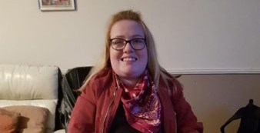Section five 5

Peer groups and the Disability Design Reference Group
Peer Groups - remote
Our peer groups are another success story, which have proved a lifeline for isolated disabled people throughout the pandemic
We received funding from the NET DPO Covid-19 Emergency Fund to offer 20 disabled people in Greater Manchester access to weekly peer group sessions using Zoom.
This funding allows us to continue to run the existing peer group of disabled women who meet for an hour on Monday afternoons on Zoom, and also have a WhatsApp group which they are using as a positive space to support each other during this time.
In this video peer group member Alex talks about why she enjoys the women’s peer group.
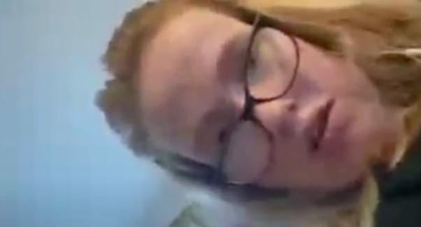
We’ve also been able to create a new open group, meeting on Fridays at 2pm also using Zoom.
Weekly sessions begin with a ten-minute Covid-19 debrief to provide mutual information and support, followed by member led discussion or activity, ending with social chat and ideas for the week ahead.

Image: Alex who attends the Women’s Peer group remotely

Breakthrough Women’s peer group story
With a member who’s been stranded in the UK as she can’t return to her native Australia, our women’s peer group is showing just how important it is to stay connected at this time.
Monique, who ended up stranded in Manchester at her sister’s house, had only meant to stay for eight weeks and has now been here over six months.
Monique is from outside Melbourne and was visiting her sisters for support following the death of her parents. After she couldn’t return home, she was referred to Breakthrough through the Council’s Learning Disability Team.
She said, “It’s been great as I’ve made friends with everyone. I’ve also managed to give up smoking and everyone in the group has helped me. When someone is feeling down, we’re there to talk to each other whatever’s happening.
“I would say these were my first friends too, I didn’t have friends in Australia.”
Everyone in the group has a similar story of support.
Gemma said’ “I went through a really bad time I didn’t want to communicate with anybody and I isolated myself. The WhatsApp group shows me I’m not on my own and there are other people out there.

It has held 9 DDRG meetings using Zoom video and fedback on a wide range of schemes.
A key part of the group’s work is carrying out site visits to new projects, making a tour of the site and giving direct feedback on improvements.
While lockdown put a stop to this site visit work, improvements from previous site visit recommendations continued to be carried out.
Changes as a result of the group’s feedback during this time includes access improvements to the newly extended Metrolink Trafford Park Line:
- Yellow platform edging renewed on both platforms at Cornbrook tram stop
- Black banding applied to the top and bottom of the visibility bands on all of the lighting columns
- Improve white lining on inbound platform steps at Shudehill tram stop
- Lowered position of existing reflective strips on lighting columns for the benefit of people using wheelchairs

Image: Shows new white lining on Shudehill tramstop steps

“If the group hadn’t been here I was going to give up on life. But with these girls it’s a group I can be part of.”
At the weekly Zoom meeting the group spends the first 10 minutes checking in and having a Covid update. If anyone is having a ‘Marley and Me’ day – where they feel like crying - members are there to listen.
Katrina said; “During the first lockdown it was really hard and I got made redundant from my job. I was having a very bad time but then the group started and it really helped.
We do Zumba together and quizzes, and some of us have joined a choir. We chat in between on WhatsApp too.”
For peer group members who live alone, Christmas in lockdown was especially difficult, but the group made sure they continued to meet over Zoom, with Halloween and Christmas parties.

Disability Design Reference Group
Now in its 12th year of operation, the DDRG is a huge success story. The group is made up of disabled people from across Greater Manchester, who have a range of impairments and can share their lived experiences of the challenges travelling on public transport.
Breakthrough manages this award-winning group on behalf of Transport for Greater Manchester.
It has proved itself essential in removing barriers to accessible transport and travel, ensuring as many people as possible are able to use public transport services.
During this time period, the DDRG members fed back remotely through email, but then moved its monthly meetings online.

Section six 6

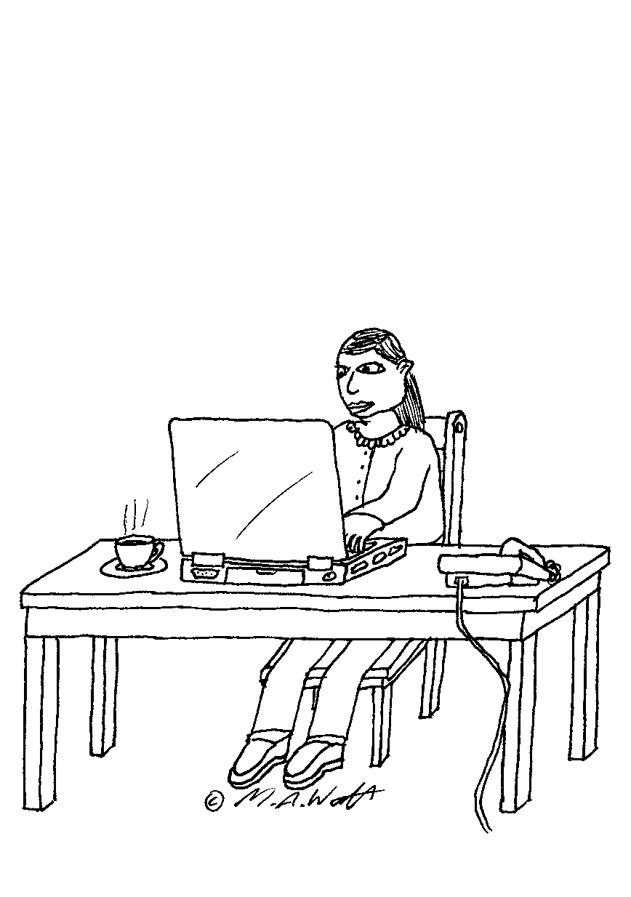

Plans for the future

We have set our key objectives until 2022.
These are part of our Strategic Plan, which we co-designed with Breakthrough clients, board and staff members at the end of 2018. These were re-set in July 2020 during the Pandemic.

Influencing government, local, regional and national agencies to address barriers to disabled people’s participation:
- We will continue to aim high and be a leader in the field of disability issues and a ‘go to’ organisation for opinion for public and VCSE sector, and other disabled people’s organisations.
- We will collaborate to create change and influence, and be focused in our influencing.
- We will develop a key ‘voice’ campaign about an issue that really matters to disabled people.
- We will be a key influencer to highlight impact of COVID on disabled people
- We will be central to reducing increased inequalities created by COVID pandemic
- We will develop and engage with ‘forums’ of disabled people to influence change
- We will develop a focus on Disability Pride

Enabling disabled people to pursue and develop their skills, aspirations and careers:
- We will continue to ensure co-designed and person- centred employment support, and build on our early successes of peer-led support.
- We want to work more collaboratively, and develop partnerships to develop and deliver services.
- We will develop our offer to reduce digital exclusion
- We will develop our services to respond to isolation and inequality impacts of COVID

Providing services so disabled people have greater choice, control and independence, and connect into their communities in a positive way:
- We want to extend our successful Community Connector and Pathways services
- We will increase our peer led services

Working towards being financially stable with healthy growth grounded in our ethos and principles:
- We will improve internal systems and invest more in staff.
- We will develop a managerial succession plan.
- We have set ourselves a big aspiration to develop a ‘2022 Enterprise’ and scope a major fundraising plan to get us there.
- Create a wider funding mix to increase sustainability.
- We will change our approach to managing risk

Illustration by Mark Watts © 2021
27

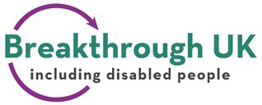
28

Get involved with us
Subscribe to our newsletter

Visit our website
www.breakthrough-uk.co.uk

Offer work
or voluntary placements to our clients within your organisation.

Volunteer with us
at one of our groups.

Make a donation

Thank you
Without the support of our funders, we couldn’t work with clients, or the cause of independence and participation.

Breakthrough UK
Follow us on Twitter: @BUKCommunity Facebook.com/BreakthroughUKLtd
Telephone: 0161 234 3950,
Text directly: 0793 994 3383 or
email us: admin@breakthrough-uk.co.uk
Kevin Hyett Suite, Abraham Moss Centre Crescent Road, Crumpsall M8 5UF

