Manchester Disability Collaborative Making Sure We Reach Everybody In Our Community
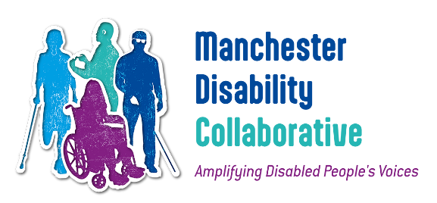
- Kyda Grabham worked with the Manchester Disability Collaborative (MDC) as part of their university placement.
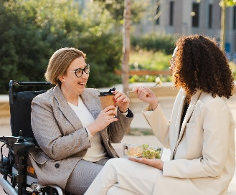
- They met many people and organisations to understand how MDC works with Disabled people in Manchester.
- MDC knows that to do good work, it must listen to many different Disabled people.
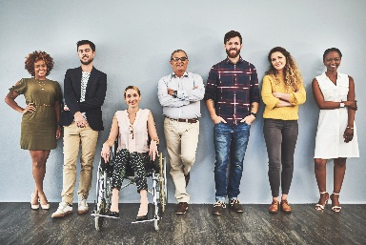
- This includes Disabled people who are also LGBTQ+, refugees, global majority
or neurodivergent
- Kyda’s work is helping MDC improve how it includes people and how it works with partners.

- MDC thanked Kyda for the way their
work will help us to do better.

What this report is about
- The report looks at who MDC is already connected with.

- It also shows which groups MDC is not yet reaching well.
- It focuses on Disabled people who face different types of barriers.

What is in the report
- MDC’s current connections
- Gaps in engagement
- Findings and recommendations
- Summaries of organisations

- Conclusion
MDC’s Current Connections

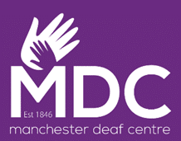
Health & Social Care
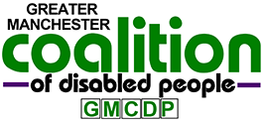
MDC works with groups like:
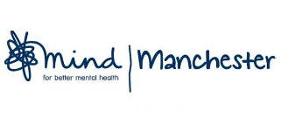
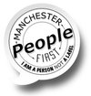
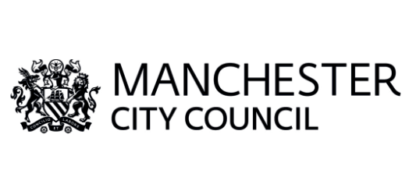
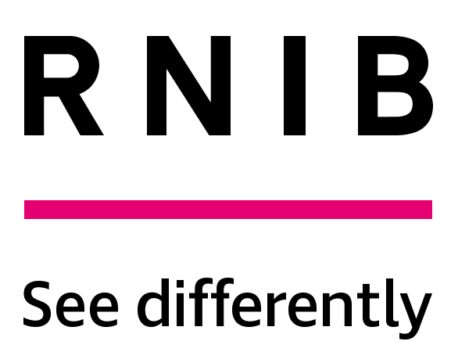
GMCDP, Manchester Disabled People’s Access Group, Manchester Deaf Centre, RNIB, Autizma, Manchester People First, Manchester Mind, Manchester City Council
Housing
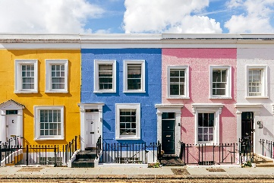
Our connections include:
GMCDP, Manchester Autism Consortium, Manchester People First, Manchester Deaf Centre
Social housing providers (Great Places, Southway, MSV, Wythenshawe)

Manchester City Council Adult Social Care
Transport
Our connections include:
Transport for Greater Manchester
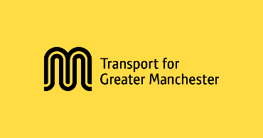
GMCDP, RNIB, Wheels for All, Research Institute for Disabled Consumers
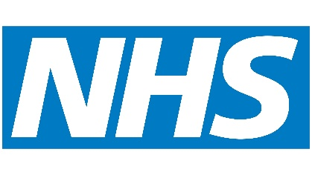
Greater Manchester Moving
NHS links
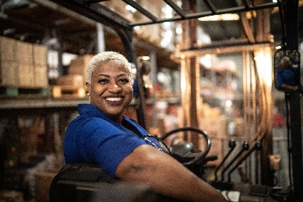
Lived Experience Experts
Employment
Our network includes:
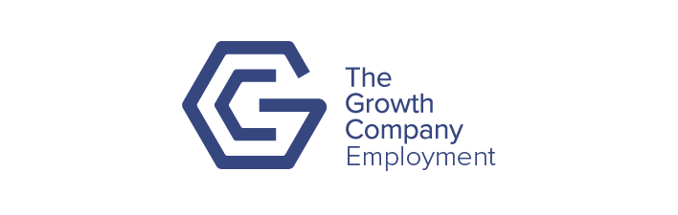
Growth Company, Good Employment Charter, Empowerment Passport, the DWP, the Manchester College, Pure Innovations
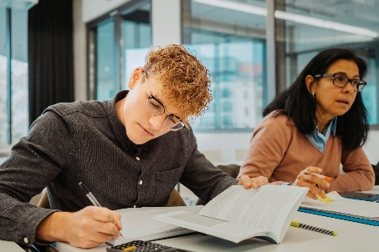
Previous links with Mustard Tree, George House Trust, Probation Service, MASH
Education
Statutory partners: Manchester College, MCC, Empowerment Passport, UCEN, Autizma, Xaverian, Loreto
Higher Education partners: University of Manchester, MMU, ALLFIE, UA92, UCEN, ULAW, Disabled Students UK

Engagement Gaps
We need stronger connections with:

- Non-verbal Disabled people
- Intersectional neurodivergent groups

- People with complex mental health needs and people who hear voices
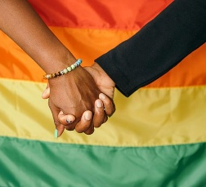
- Global majority communities
- Refugees and asylum seekers
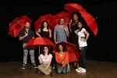
- Homeless people
- LGBTQ+ Disabled people
- Sex workers
Findings & Recommendations
1. Cultural competency
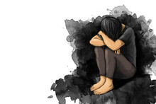
- In some cultures, disability is seen as shameful.
- MDC must understand this to engage people well.
- Beyond Empower is doing focus groups to help improve cultural competency.
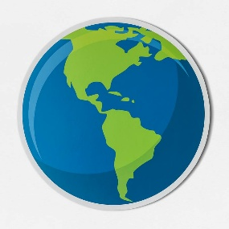
2. Work with local groups who use global perspectives
- Charm Mental Health uses ideas from around the world.
- Working with them can help MDC reach global majority communities and people with complex mental health needs.
3. Reduce digital exclusion

- Many intersectional communities struggle with digital access.
- MDC should:
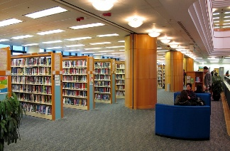
  - Share information in libraries and community centres
This Photo by Unknown Author is licensed under CC BY
  - Offer online and in-person engagement
  - Use existing partner organisations to spread information

4. Build long-term relationships
This Photo by Unknown Author is licensed under CC BY-NC
- Short-term engagement feels tokenistic.

- MDC should focus on keeping people involved throughout our work.
5. Use existing intersectional connections
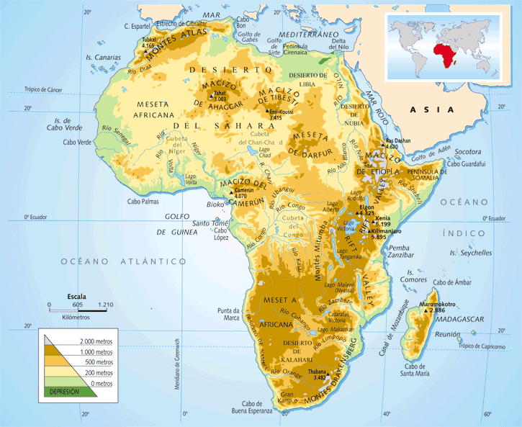
- Work more closely with Empowerment Passport and the TIDA Initiative
This Photo by Unknown Author is licensed under CC BY-SA-NC
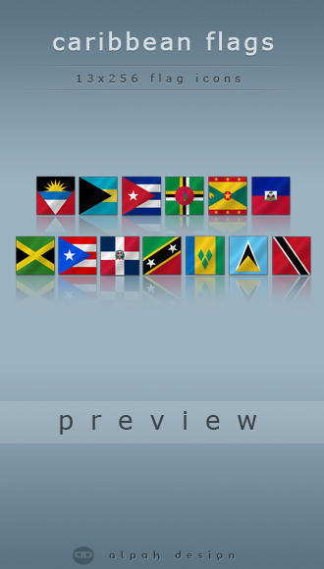
6. Work more with other CHEM sounding boards
This Photo by Unknown Author is licensed under CC BY-NC-ND
Examples:

- African & Caribbean Sounding Board
- Bangladeshi Sounding Board
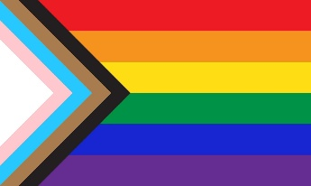
- Inclusion Health Sounding Board

- LGBT+ Sounding Board
- Pakistani Sounding Board

Each Sounding Board has projects MDC could collaborate on, such as:
- Digital exclusion

- Mental health
- Incontinence awareness
- Accessible LGBT+ training
- GP access
Organisation Summaries
Successful outreach
Charm Mental Health Charity
Supports people with mental health needs, neurodivergence, and people who hear voices. Uses community and rights-based approaches.
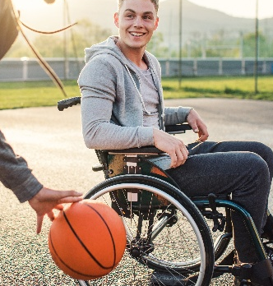
Empowerment Passport
Helps Disabled and neurodivergent people share their needs in education and employment.
Beyond Empower
Helps Disabled people access sports and active lifestyles.

Manchester People First
Learning Disabled people’s self-advocacy group.
George House Trust
Supports people living with HIV.
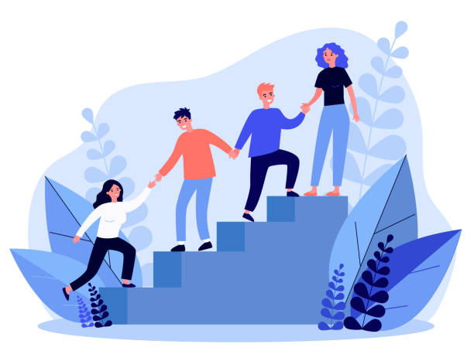
Proud2b Parents
Supports LGBTQ+ families.
Afrocats
Supports socially excluded people, especially Black women and young people.
Ananna
Supports Bangladeshi women with community activities and advocacy.
BHA for Equality
Health awareness and access for African and Caribbean communities.
Unsuccessful outreach
We were unable to connect with these organisations.
- Guidance Hub
- ALLFIE (Alliance for Inclusive Education)
- Back on Track
- Manchester BME Network
- Mustard Tree
- MASH (Manchester Action on Street Health)
- Hearing Voices Network
- CAHN (Caribbean and African Health Network)
Ongoing outreach
- TIDA Initiative
- ADHD Babes
Conclusion
- MDC has many strong connections but still has gaps in reaching intersectional communities.
- The report gives clear recommendations to improve inclusion and engagement.
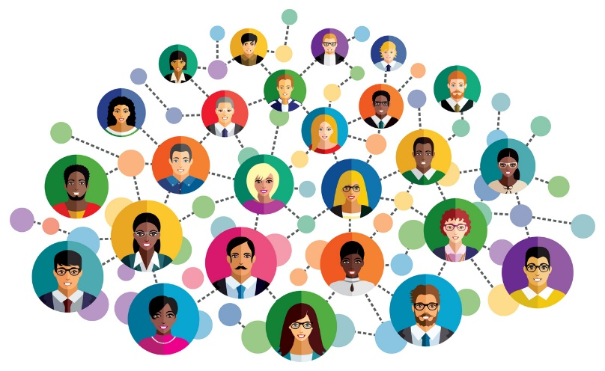
- MDC will continue building relationships and improving access for all Disabled Mancunians.

